1. Introduction

This report presents a comprehensive analysis of customer shopping data of Turkey sourced from kaggle. Each sheet provides distinct but interrelated data on customer shopping behaviors, including sales by category and shopping malls, demographic factors, monthly sales trends, and payment preferences.

2. Sales by Category and Malls

Key Findings: Clothing and Technology are the highest-performing categories. Sales vary significantly across malls, with malls like Istinye Park and Kanyon leading in most categories.

Insights: Certain malls have niche markets, e.g., high Technology sales in Emaar Square Mall.

Opportunities: Potential market growth can be explored in underperforming categories at specific malls.

3. Demographic Factors

Analysis: Customer demographics vary across malls. Malls like "Mall of Istanbul" attract a broad range of age groups, while others like "Zorlu Center" are more popular among specific age brackets.

Insights: Older age groups (45-69) frequent malls like "Metropol AVM" and "Metrocity."

Recommendations: Tailoring marketing strategies to the predominant age groups at each mall could be effective.

4. Monthly Sales Trends

Seasonal Trends: A significant drop in sales across most categories is observed in March.

Performance Analysis: Categories like "Shoes" and "Clothing" show high sales in January and February.

Strategy Implications: Inventory and marketing efforts should be adjusted seasonally, focusing on high-performing categories in peak months.

5. Payment Trends

Preferred payment technique: Cash is the favored approach of payment for 25-34 year olds, accompanied by way of credit card and debit card.

Customer Behavior: The preference for cash might indicate a trend towards direct transactions.

Suggestions for improvement: Improving cash management and exploring credit card promotions or rewards can align with consumer preferences.

6. Conclusions

The survey reveals important insights into sales trends, customer demographics and payment preferences.

Strategic recommendations include:

Exploiting market opportunities in underperforming categories at specific malls.

Tailoring marketing and product strategies to the demographic profiles of customers frequenting each mall.

Seasonally adjusting inventory and marketing efforts based on monthly sales trends.

Enhancing the customer payment experience in line with the preferences of key demographic segments.7. Appendices

1. sales by category and shopping malls- pivot table with color formatting.

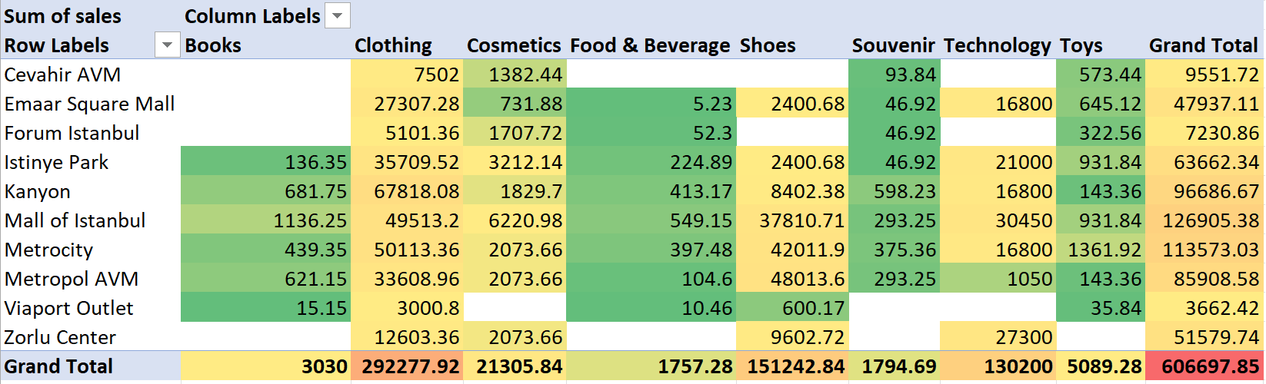

2. demographic factor – stacked bar chart.

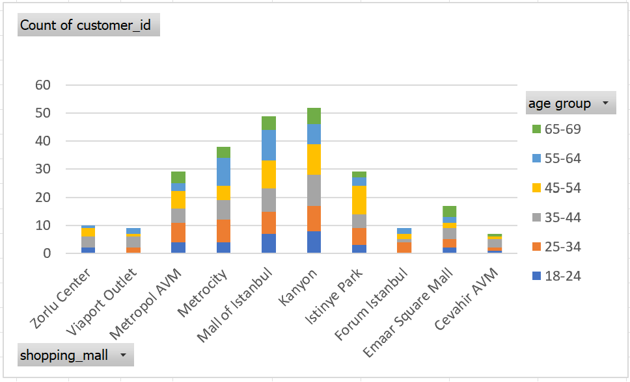

3.monthly trends- line chart.

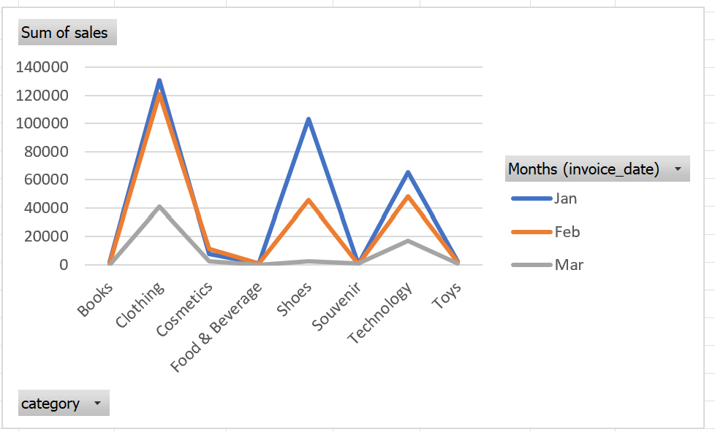

4.payment trends- bar chart.

